Diagrams and Topology Descriptions – Introduction to Model-Driven Network Automation Using NETCONF

Network Topology
This lab uses a simple, single‑device topology. The Cisco IOS XE device is provided either through the NDG NETLAB+ DevNet environment or as a local IOS XE / CSR1000v virtual router when the lab is completed using the DEVASC VirtualBox VM.
Automation tasks are performed from the DEVASC Linux virtual machine using Python and the ncclient library. The DEVASC VM communicates directly with the Cisco IOS XE device using NETCONF over SSH (TCP port 830) to retrieve and modify structured configuration data.
No additional network devices or inter‑device dependencies are introduced. This intentionally limited topology is designed to keep the focus on model‑driven automation concepts, safety, and validation rather than on network scale or protocol interaction. Figure 1 below illustrates the logical topology used in this lab:
Figure 1
NETCONF-Based Automation Topology: [ DEVASC-LABVM ] ---- NETCONF (SSH / TCP 830) ----> [ IOS XE / CSR1000v ]

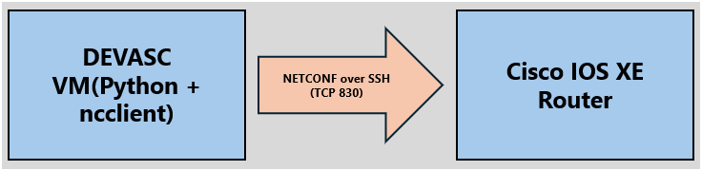

If using the NDG NETLAB+ Environment, the topology will look as such:

Figure 2.
NDG NETLAB+ topology (includes CSR1000v)
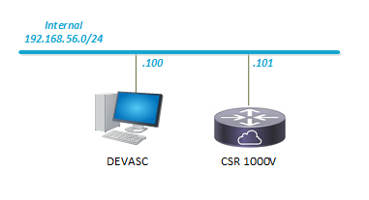

Environment Assumptions
This topology represents a logical example of the lab environment. IP addresses, interface identifiers, credentials, and NETCONF connectivity details shown or referenced are provided as examples and may differ depending on the student’s local lab environment.
Students are expected to verify actual device parameters before performing configuration or automation tasks.

